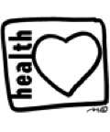

Sand Pine Elementary School

Red Ribbon Week 2018

Celebration of a Healthy Life

Monday, Oct 22nd **Cuddle Up to a Healthy Life** – Wear your PJs.

Tuesday, Oct 23rd **Too Cool for Distractions** – Wear a hat & sunglasses and stay focused on your dreams.

Wednesday, Oct 24th  **Red Day** – Wear as much Red as possible.

Thursday, Oct 25th **Wacky Tacky Day** – Wear crazy socks or clothes that clash and have fun being unique!

Friday, Oct 26th  **Character Parade**

 