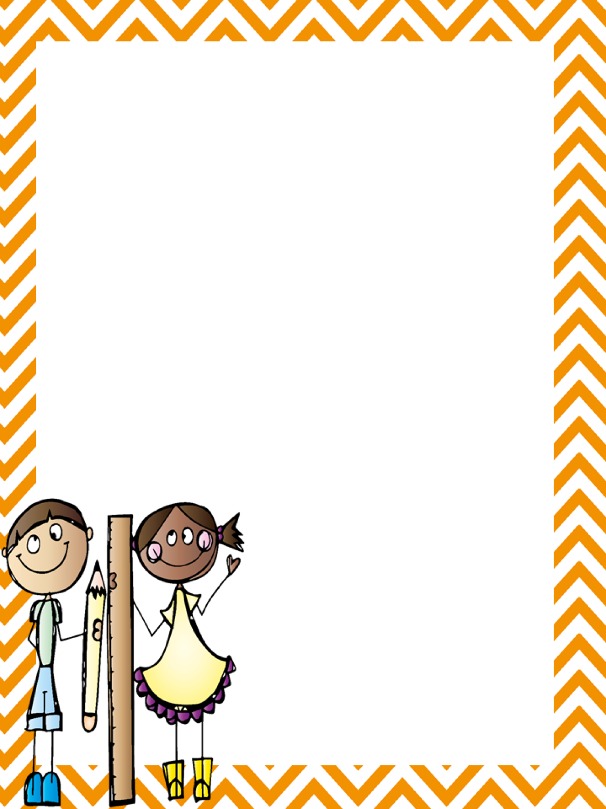

One **labeled** pencil box. In the pencil box, please place the following items to help your child have a successful first day:

Two sharpened pencils One large eraser

Scissors Two glue sticks

One box of crayons

One **labeled** Plain Plastic Folder with prongs, and pockets

* **3 Composition Books**

**\*\*\* Primary only**

available at

Walmart and

Office Depot

* 24 Sharpened Pencils (Not Dixon Brand)
* 3 Boxes of Crayola Crayons
* 1 Box of Crayola Markers
* 1 Packet of 2-inch pink erasers
* 24 glue sticks
* 2 Reams of Printer Paper (priority)
* 1 Pair of Scissors
* 2 boxes of tissues
* 1 package of Lysol Wipes
* 1 Paper Towel Roll
* 1 box Ziploc re-sealable sandwich bags
* 1 box Ziploc re-sealable gallon bags

Sand Pine Elementary School

First Grade Owls Team

2017-2018