Sand Pine Elementary 2nd Grade Supply List
2019-2020
One labeled pencil box. In the pencil box, please place the following items to help your child have a successful first day:

1 thin yellow highlighter 1 pair of Scissors
1 box of 24 Crayons 1 box of Washable Markers

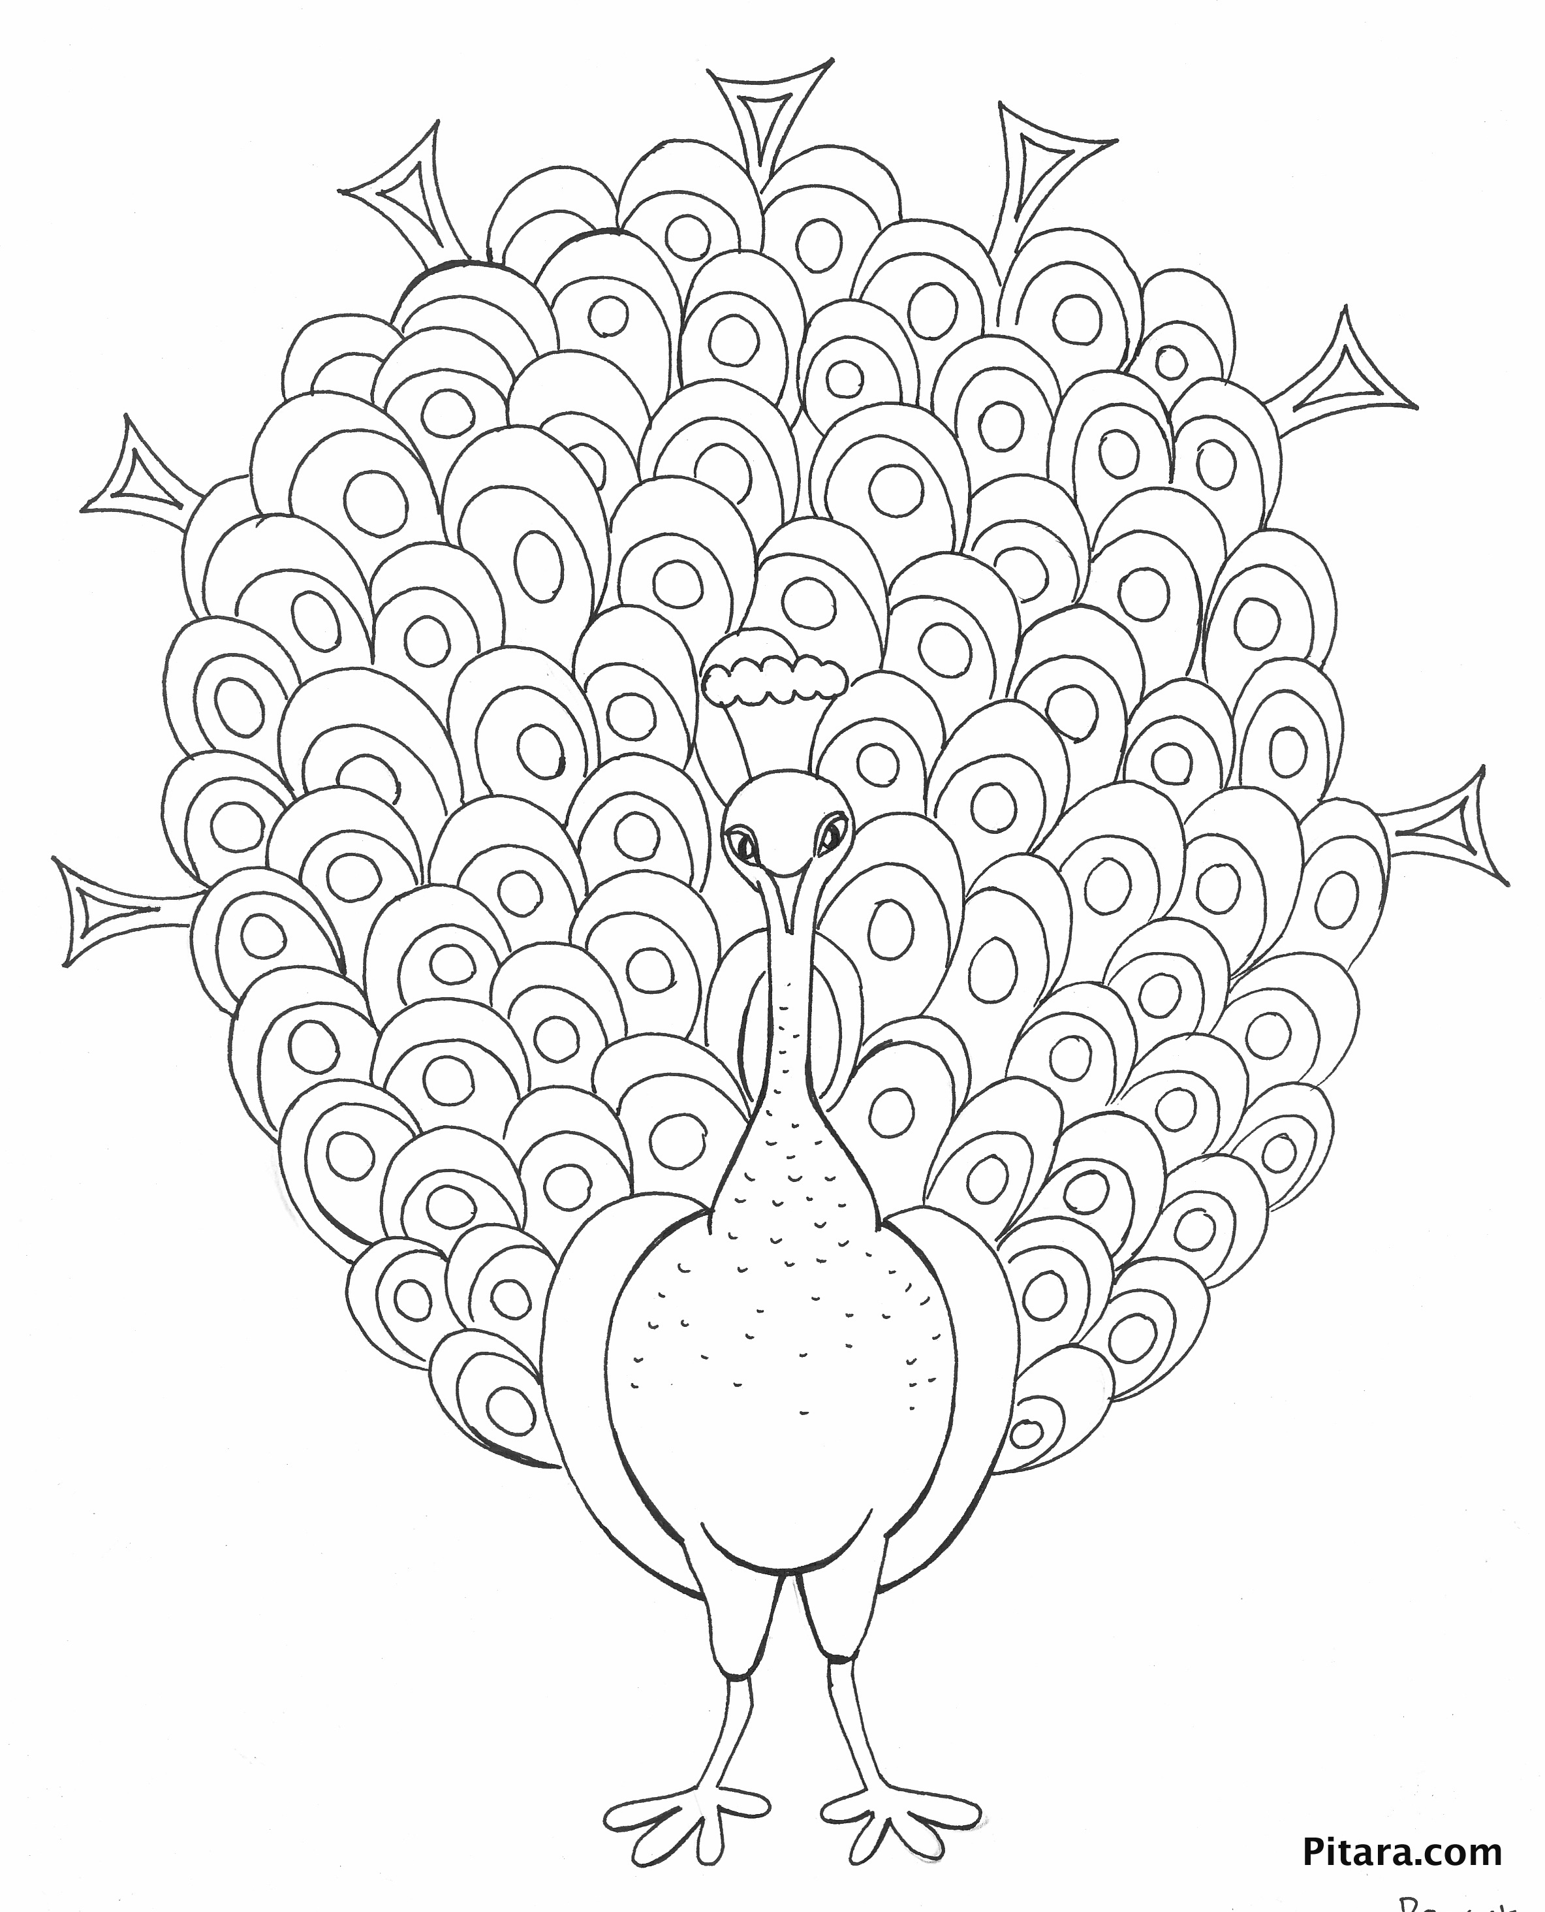
Please have your child bring the following
unlabeled items to class:
- 5 black thin dry erase markers
- 24 Pencils, sharpened
- 4 Glue Sticks
- 2 large erasers
- 1 Pencil Box (Hard Plastic, standard size)
- 2 pack of wide-ruled notebook paper
- 1 Composition Book (Wide Ruled)
- 1 White 1/2” Binder (with plastic sleeve)
- Folders: (Plastic, 2 pocket, with prongs)
  - 1 Red
  - 1 Blue
  - 1 Green
  - 1 Yellow
- 2 Boxes of Tissues
- Lysol Wipes

- 1 Ream of white copy paper

Wish List Items: (not required)

**Colored Pencils Pencil Topper Erasers
**Expo Markers Notebook Paper (wide ruled)
**Ziploc Bags (sandwich size) Card stock
** Paper towels Pink Erasers
Lysol Wipes Colored copy paper
Extra Plastic Folders School Glue (liquid)
Band Aids (non latex) Post It Notes

