Sand Pine Elementary School
2019-2020
Kindergarten Supply List
Important: Please bring your supplies on Meet the Teacher Day. Please place in the pencil box 1 box of crayons, 2 sharpened pencils, 1 glue stick, and 1 pair of scissors.

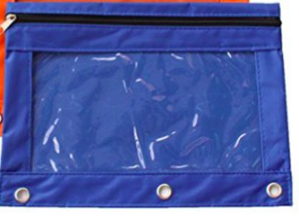
1 plastic pencil box (with name on it)
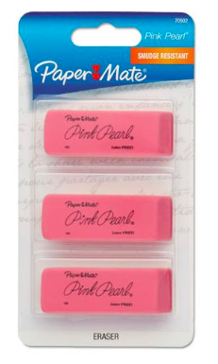
1 zipper binder pouch
1 pack of sharpened pencils
1 pack of pink erasers
4 Boxes of Crayola Crayons
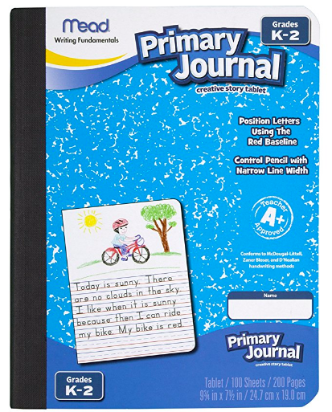
1 Box of Crayola Markers
2 package of Expo dry-erase markers
18 glue sticks
1 Primary Composition Book-labeled with name
(available for order on Amazon, item #9554)
1 Wide-Ruled Composition Book-labeled with name
2 Red Plastic 3 prong Folder-do not label
1 Pair of Scissors
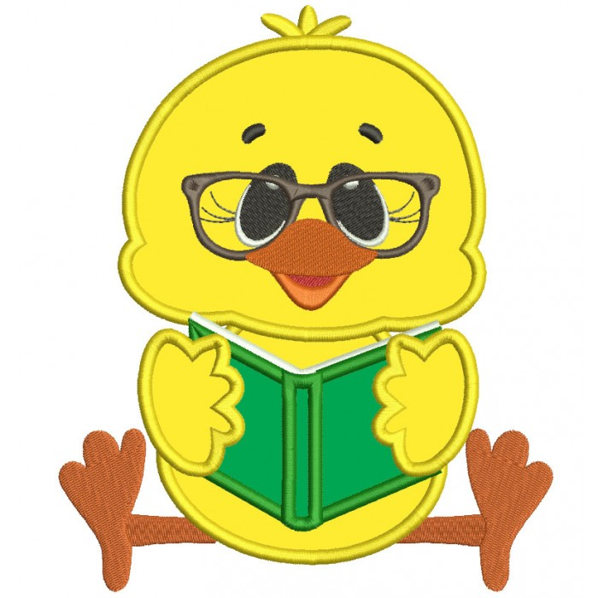
1 box of tissues
2 packages of Lysol Wipes
1 pack of baby wipes
1 Ream of Printer Paper
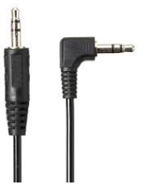
1 box Ziploc sandwich bags
1 box Ziploc gallon bags
1 Headphones (straight jack only, no ear buds)

