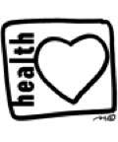

Sand Pine Elementary School

Red Ribbon Week 2019

Celebration of a Healthy Life

Monday, Oct 28th **Cuddle Up to a Healthy Life** – Wear your PJs.

Tuesday, Oct 29th **Too Cool for Distractions** – Dress fancy and cool, like you are living the dream!

Wednesday, Oct 30th **Red Day** – Wear as much Red as possible.

Thursday, Oct 31st **Character Parade**

Friday, Nov 1st  **Lift yourself up** – Dress like you do when you are doing something that makes you happy!

 