Sand Pine Elementary

2023-2024
Please bring these items for the first day of school!

- One labeled pencil box. In the pencil box, please place the following items to help your child have a successful first day:
* 2 sharpened pencils * 1 large eraser * Scissors
* 1 box of crayons. * 2 glue sticks

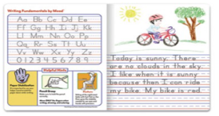
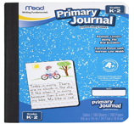
- 2 Composition Books
***Primary Only***
(available at Walmart, Office Depot, Amazon)
- 1 blue plain plastic folder with prongs and pockets
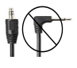
- 1 red plain plastic folder with prongs and pockets
- 1 green plain plastic folder with prongs and pockets
- 1 purple plain plastic folder with prongs and pockets
- 1 pair of headphones (straight jack only, no earbuds please)
- 36 sharpened pencils
- 4 boxes of Crayola crayons
- 2 boxes of Crayola markers
- 1 pack of 2-inch erasers (Pentel white erasers)
- 2 packs of thin black Expo markers for student’s dry erase boards
- 1 pack of Expo markers for teacher’s whiteboard
- 1 ream of printer paper
- 1 pair of safety scissors
- 1 medium size bottle of hand sanitizer
- 2 containers of Clorox/Lysol wipes
- 1 roll of paper towels
- 1 coloring book

Optional Supplies:
Baby wipes
Play-Doh
Hand sanitizers
Multi-culture crayons
Fun Stickers

