Sand Pine Elementary 2nd Grade Supply List
2023-2024
One labeled pencil box (hard plastic, standard size)
In the pencil box, please place the following items to help your child have a successful first day:
1 pair of scissors
1 box of 24 crayons
2 sharpened pencils
1 glue stick
*Your child will also need labeled headphones*

Please have your child bring the following
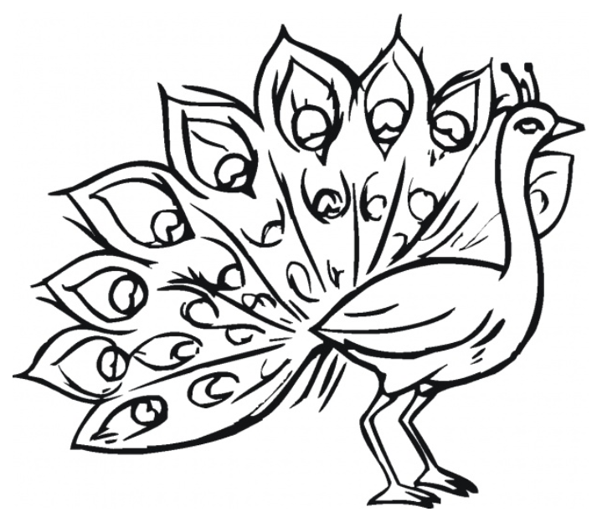
unlabeled items to class:
- 20 black thin dry erase markers
- 2 thin highlighters
- 24 pencils, sharpened
- 25 pencil cap/top eraser
- 2 boxes of 24 crayons
- 1 containers of Clorox Wipes
- 1 roll of paper towels
- 4 boxes of tissues
- 1 box of Band-Aids (non-latex)
- 4 "Magic Eraser" cleaning sponges
- 1 box of Ziploc bags (sandwich size)

Please have your child bring the following labeled items to class:
- 1 white 1/2” binder (with plastic sleeve)
- 1 wide ruled composition notebook
- Folders: (plastic, 2 pocket, with prongs)
  - 1 red
  - 1 blue

Optional Supplies: (not required)
** Post It Notes
** Expo Markers
** dry erase pockets
** 1 box of Ziploc bags (gallon size)

