Sand Pine Elementary School
2023-2024
Kindergarten Supply List
Important: Please bring your supplies on Meet the Teacher Day.
Please place in the pencil box: 1 box of crayons, 2 sharpened pencils,
1 glue stick, and 1 pair of scissors.
1 plastic pencil box (with name on it)
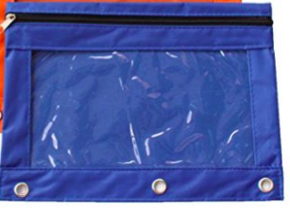
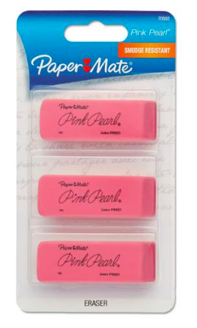
1 zipper binder pouch
1 pack of sharpened pencils
1 pack of pink erasers
5 boxes of Crayola crayons
2 packages of Expo dry-erase markers
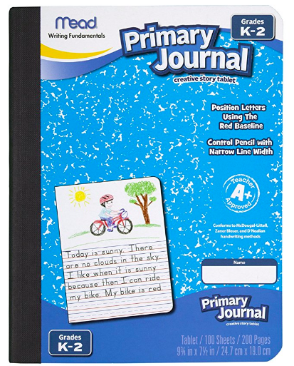
(1 colored and 1 black)
24 glue sticks
2 primary composition book-labeled with name
(available for order on Amazon, item #9554)
1 red plastic 3 prong folder-do not label
1 blue plastic 3 prong folder-do not label
1 pair of scissors
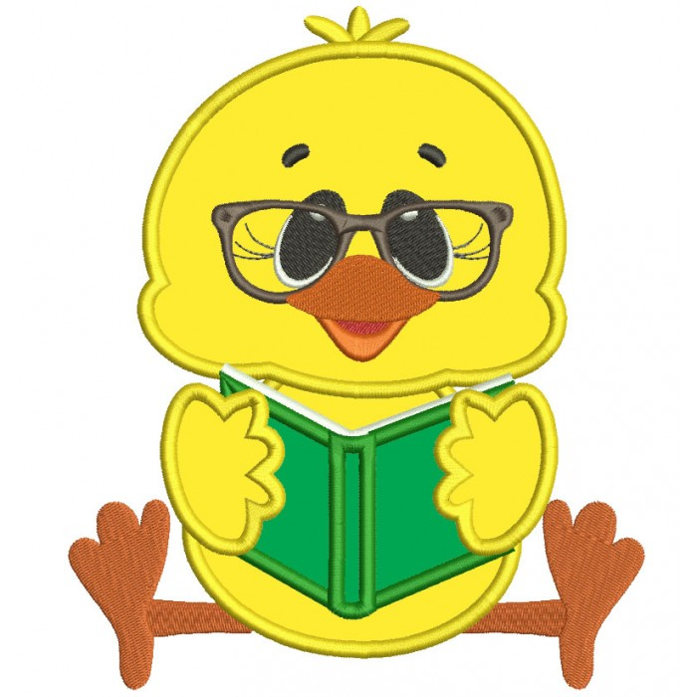
2 boxes of tissues
1 box of Band-Aids
2 packages of Lysol wipes
2 packages of baby wipes
2 reams of copy paper
1 pack of paper towels
Headphones – labeled with name

Optional: stickers, Play-Doh

