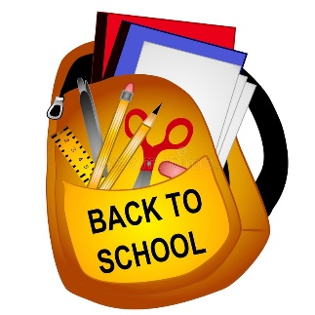
Sand Pine Elementary- Supply list 2023-2024
K-1-2 PUFFINS
*One labeled pencil box. In the pencil box, please place the following items to help your child have a successful first day: 2 sharpened pencils, 1 large eraser, scissors, 1 box of crayons, 2 glue sticks *
- 2 PRIMARY composition books
- 1 plain blue plastic folder with prongs and pockets
- 1 plain red plastic folder with prongs and pockets
- 1 pair of headphones (comfortable and durable)
- 36 sharpened pencils
- 4 boxes of Crayola crayons
- 2 boxes of Crayola markers
- 1 pack of 2-inch erasers
- 12 glue sticks
- 1 bottle of Elmer’s glue
- 2 packs of thin black Expo markers for student’s dry erase boards
- 1 ream of paper
- 1 pair of scissors
- 1 medium size bottle of hand sanitizer
- 1 pack of baby wipes
- 1 container of Clorox/Lysol wipes
- 1 roll of paper towels
- 1 pack of construction paper
- 1” hard binder with pockets
- 2 boxes of tissue

Optional Supplies:
Extra Paper towels Play-Doh Ziploc Bags (gallon, quart/sandwich)
Gallon of drinking water Plastic forks
Extra Clorox/Lysol wipes Paper plates

In a Large Ziploc bag put an extra change of clothes: 1 pair of underwear, 1 pair of socks, 1 pair of shorts and a T-shirt.

